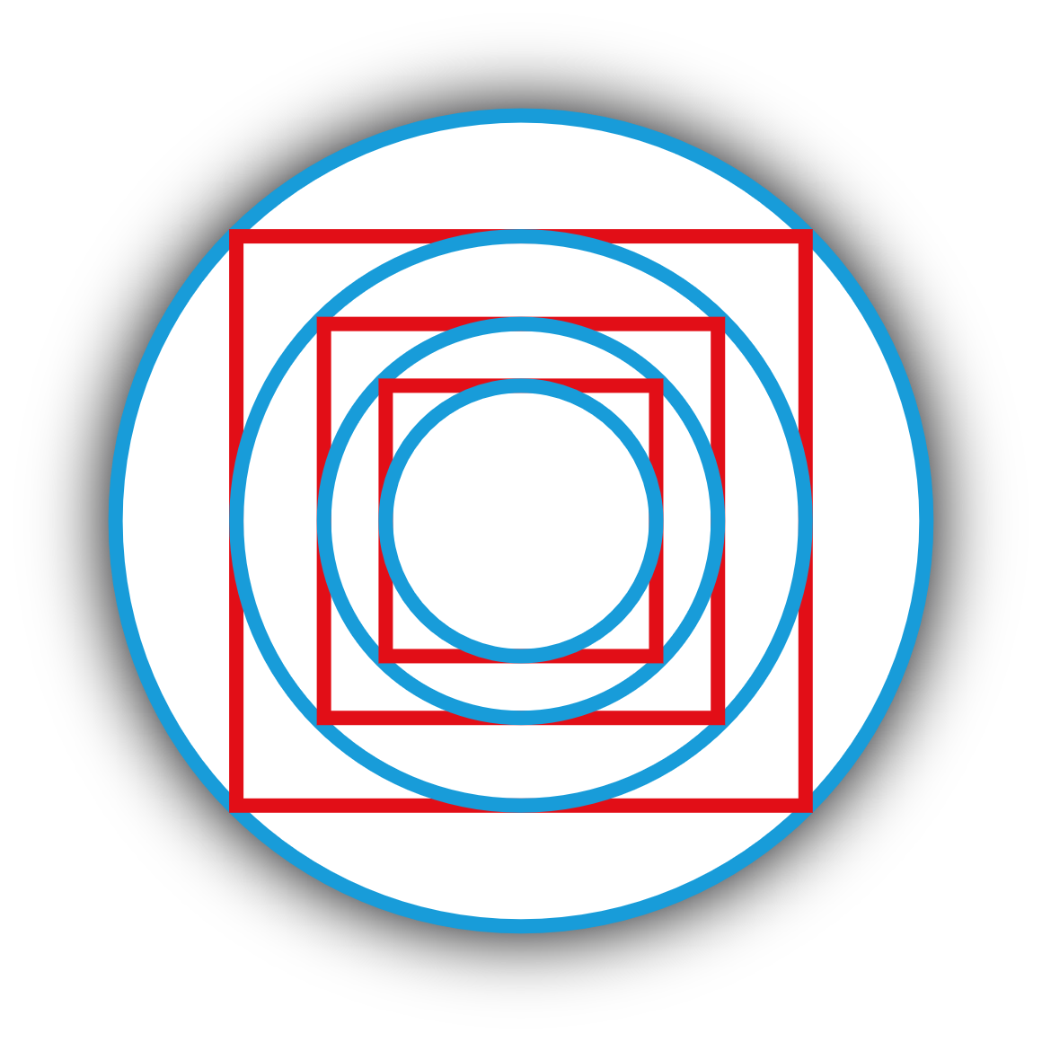
CBA 2 TEMPLATE
provided by
JUNIOR MATHS
https://juniormaths.ie/
(€10 classes. Digital Lessons. One-to-One Grinds. And more!)
Part of the EXAMS.IE family!
https://exams.ie/
(Delete this page)

CBA 2: STATISTICAL INVESTIGATION

(Insert image below)

INSERT TITLE HERE
INSERT SUBTITLE HERE
by
INSERT NAME HERE

Table of Contents
Introduction page 4
Method page 5
Results page 6
Discussion page 7
Conclusion page 8
(Change page numbers above when completed if necessary.)

Introduction
On this page:
- Explain what your title means.
- Explain why you chose this topic.
- Explain what areas of maths you will use.
- Explain what data you will collect.
- State any assumptions that you will make.

Sample introductions located at:
https://juniormaths.ie/cba

Method
On this page, you should explain how you performed your investigation.
- Write your method 1) in past tense, 2) in steps and 3) in chronological order.
- If you collected data:
  - state how that data relates to the variables that you are looking for
  - state the units of the data
- If you performed research:
  - state the research that you did
  - explain how you performed the research
- If you performed mathematics:
  - state the equations/formulae that you used
  - explain why you used those equations/formulae

Sample methods located at:
https://juniormaths.ie/cba

Results
On this page, you should represent the data that you collected.
- This can be done using tables, graphs etc.
- If diagrams are included, make sure that diagram is labelled correctly!
- Be sure to include units where appropriate.
- Hand-drawn tables and graphs are totally fine!

(Insert image(s) below)

Sample results located at:
https://juniormaths.ie/cba

Discussion
On this page, you should interpret your results.
- What do your results show?
  - Refer to your data, graphs etc. when answering this question.
- Were your results as you expected, or surprising?
  - Your initial prediction not being right is not a bad thing!
  - Explain why there is a difference between the predicted results and the actual results.

Sample discussions located at:
https://juniormaths.ie/cba

Conclusion
On this page, you should summarise your investigation.
- If your title is in the form of a question, you should answer that question directly here.
- Do you believe your results are exact, or just an approximation?
- Can you think of ways that you could improve on your method?

Sample conclusions located at:
https://juniormaths.ie/cba

